The Train Theater, International Puppet Festival
Jerusalem, August 9-13, 2015

PANEL:
Puppet Theater For Toddlers: How to Do It?
Sharing our Experience and Ideas
August 11, 2015

Organized and produced by:
Dr. Naomi Yoeli, Dramaturge of the Train Theater
Dalia Maayan, General & Artistic Director of the Train Theater and the International Puppet Festival

Moderated by: Dr. Naomi Yoeli

Dear friends and colleagues,

Everyone knows that, from the moment a child is born, he or she responds to play. The puppeteers among us observe the moment when a baby can recognize an object or person – a puppet, doll, toy, story or mother – as something separate from itself, and begin to interact with it. This is the moment when the next puppeteer in the family, or perhaps a puppet theater enthusiast, is born.
Over the last few years, many creative efforts have been made to produce theater performances, puppet theater and storytelling specifically for toddlers, and even for young babies, from birth to three years old. At this year’s International Puppet Theater Festival, we will showcase a wealth of performances for tots and toddlers. We felt that this would be a valuable opportunity to hold a panel discussion with the festival’s guest puppeteers, educators and researchers, with the aim of expanding the conversation on this subject. In doing so, we hope to inspire a renewed desire among multidisciplinary artists to stimulate interest and thought regarding this art form among children’s cultural guardians: their parents, caregivers, kindergarten teachers and grandparents.

Dalia Yaffe-Maayan & Naomi Yoeli

Program and Speakers:

Sibylle Tröster:
“Animal Train” – The dramaturgy of a children’s book on stage
Sibylle Tröster – General and Artistic Director of Theater Waidspeicher and Synergura Festival, Erfurt, Germany

Ajda Ross:
“Turlututu” – An interactive performance for small children
Ajda Ross – Artistic Director of Lutkovno Gledališče Ljubljana (Lubliana Puppet Theater), Slovenia

Stanislav Doubrava & Vítek Peřina:
“About the Lamb that Fell from the Sky” – Basic principles of our first show for toddlers
Stanislav Doubrava – Director of the Naive Theatre and Mateřinka Festival, Liberec, Czech Republic
Vítek Peřina – Author and Dramaturge, Naive Theatre, Liberec, Czech Republic

Antonio Catalano:
“Tic Tac Tic Tac” – The creation of sensitive worlds for babies
Antonio Catalano – Artist and artisan of Universi Sensibili, Casa degli Alfieri, Italy

Dr. Shlomo Ariel:
Theater as a research laboratory of early childhood
Dr. Shlomo Ariel – Clinical psychologist and family therapist
Author of “Children’s Imaginative Play: A Visit to Wonderland”

Ran Cohen-Aharonov:
Why is puppet theater beneficial for young children?
Ran Cohen-Aharonov – Early childhood specialist, children's author, Director of Early Childhood Department at The Institute for Democratic Education

Shachar Marom:
Baby Einstein vs. Object Theater
Shachar Marom – Object theater artist and Co-Artistic Director of the International Puppet Festival, Jerusalem

Hila Flashkes:
Opher and Ophra, an illustrated story by Oded Burla
Hila Flashkes – Multidisciplinary artist, puppeteer, graphic designer, typographer and animator

Galia Levi-Grad:
Shushu my Mentor: Puppets in storytelling for toddlers
Galia Levi-Grad – Visual theater artist, storyteller and puppeteer at the Train Theater
Dr. Naomi Yoeli – Puppeteer and Dramaturge at the Train Theater
Video Editor: Yonatan Zur – Film director, producer and editor

The panel discussion can be viewed here.

View the video “Yami and Tamar – Babies Telling Stories” here.

Naomi:

Dear friends and colleagues,

I am so happy that our guests at the International Puppet Festival in Jerusalem have all accepted our invitation to participate in this panel concerning puppet theater for toddlers. We have asked our guests from abroad, who are presenting their shows for toddlers in this festival, to share their experience and ideas about how we can create puppet theater for very young audiences. Kindly, all of them have agreed, and each one will give a short presentation concerning their stage work and work in process for toddlers.

We have also asked a few Israeli puppeteers and experts in early childhood education and children’s imaginative play to share their experience with us.
The aim of this panel is to broaden our artistic horizons and stimulate new ideas. In a way, for us, this panel is the beginning of a theater laboratory for toddlers.

Like some of our guests, we at the Train Theater also have limited experience in creating puppet shows and story hours for toddlers. Luckily, in this year's festival, we have four shows dedicated specifically to very young audiences. One of them, the Israeli "Balloons," is seven months old…
Dalia and I, therefore, thought this would be a perfect opportunity for us all to get together and discuss this intriguing subject, i.e. what are the special considerations in creating shows for toddlers; what is special about stage adaptation and stage language; what is the process of creating the dramaturgy; is there a specific way to instruct the puppeteers, etc.

I would like to invite Mrs. Sibylle Tröster, General and Artistic Director of Theater Waidspeicher and the Synergura Festival in Erfurt, Germany
to speak about the show “Animal Train” and The dramaturgy of a children’s book on stage.

Sibylle Tröster :
“Animal Train” – The dramaturgy of a children’s book on stage

The Theater Waidspeicher and Synergura Festival in Erfurt, Germany, have a repertoire of 20 shows with 300 performances per year.
We are very delighted to have been invited to this year's festival with our show "Animal Train: A Big Day for a Little Train." I would like to briefly present the dramaturgy of adapting a children’s book to the stage.
I started as a dramaturge myself, before I became a theater director. I understand dramaturgy, especially for children, as the structure of a performance. I would like to give you a glimpse of the show you will see starting tomorrow, through a little trailer we have prepared for you here.

“Animal Train” is a show for three-year-old children. I think that we need to approach work for three-, four- and five-year-old children differently, so we have different productions for each age group. But we have never created a show for two-year-old children. For me, the child must be able to understand theater as a kind of "alternate reality." Of course, it is impossible for a small child to understand that this is Art, but he can understand that this is another kind of reality. Somehow, we should help children understand that this is another reality.
Even though a young child's imagination is not shaped by the conventions of theater, the child is still totally open to this kind of experience of another reality by the age of three.

"Animal Train" is based on a children’s book by an English illustrator, Christopher Warmell, and was published in 2000. The German edition was published in 2001, with the title "Three Big Friends." The friends are Mrs. Elephant, Mr. Bear and Mr. Beaver. The train driver feels a tickle in his toe. He knows that something special is going to happen today, and so it transpires that these three big animals squish themselves into his little train.
Together with the train driver, they go on a tour in the city and, of course, the train becomes much too overloaded. When a bee crawls on the trunk of Mrs. Elephant, an accident occurs. Nobody is injured, of course, but the animals spill food all over the audience’s space. The children are now asked to help, and are also invited to nibble little bits of sweets (but only one sweet for each child…).
Generally speaking, the story is about a rule, breaking the rule, and re-establishing the rule with the children’s help. And, of course, there is a happy ending.
For three-year-old children, it is very important that the cast not be too big, and that it have one or two people who function as mediators between the story and the children. For the actor-puppeteer in this show, this is a very big challenge: he is both the train conductor, the head of the train station, a puppeteer and animator of the puppets. It's quite stressful for him, but also very funny, both for him and for the children.

The setting:

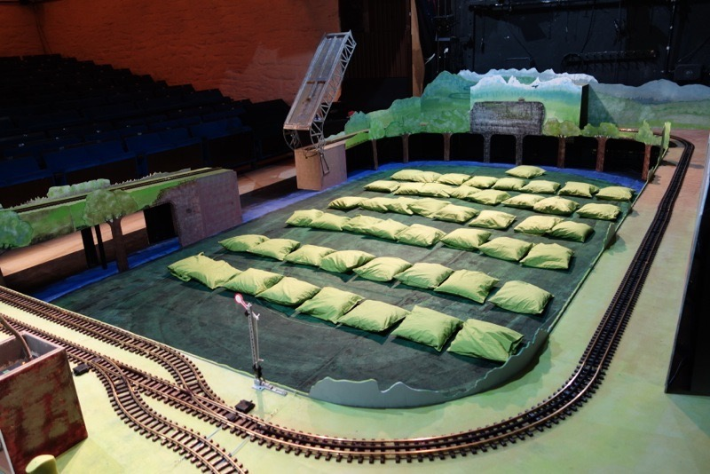
The set is designed as a railroad. All 40 children sit on cushions within the railroad set. At the beginning, the right side is open, as an entrance for the conductor-puppeteer. He invites the children in and checks their tickets. As they enter the set, they become part of it, while the train moves around them. In a way, because they are all together, the children become a kind of community, at least I hope they do…

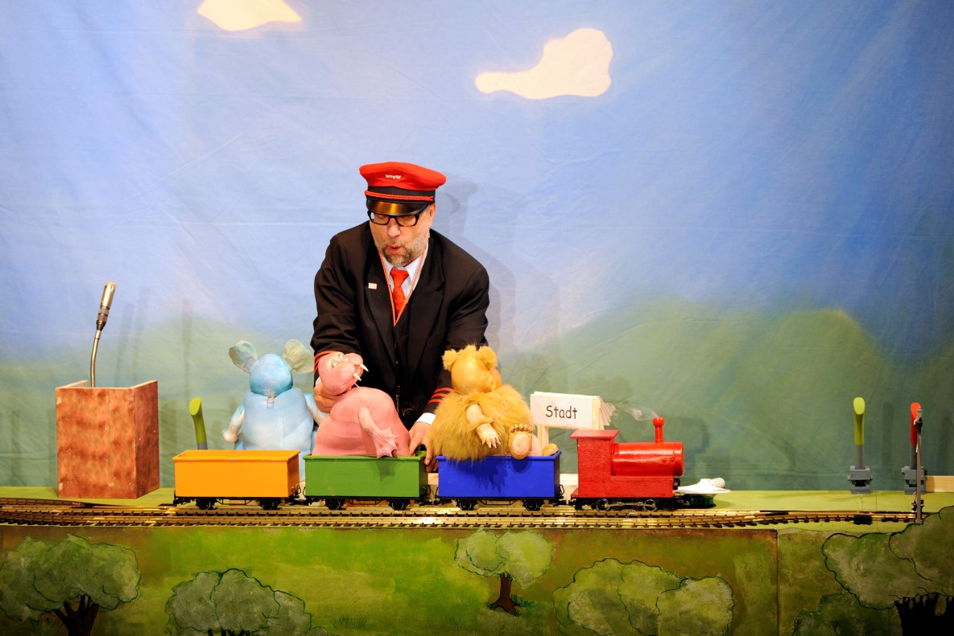

The puppeteer animates the animals and performs the "station drama" on the performing table. At each station, one of the animals boards the train, while the fourth station is for shopping in town. This "station drama" is intended and designed to be repetitive in style and action.
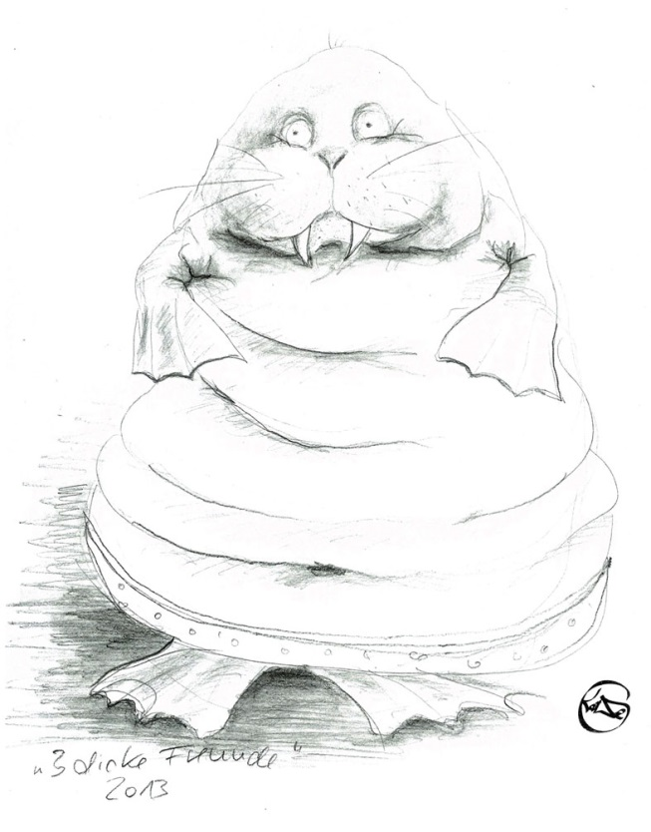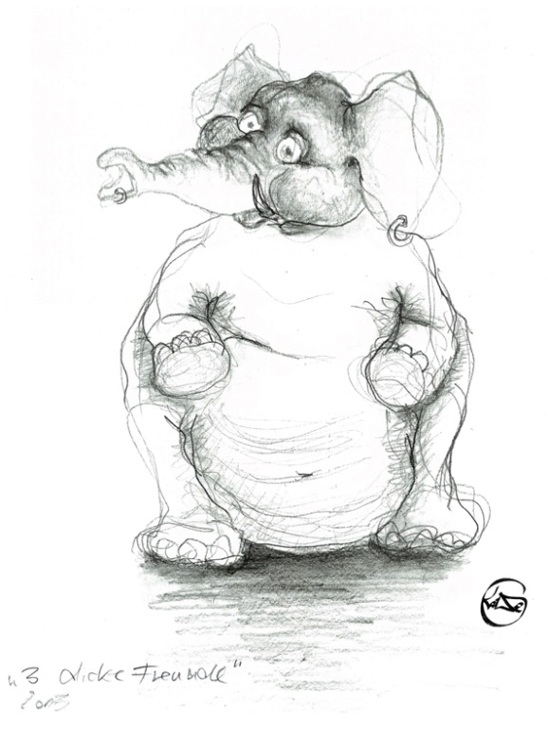

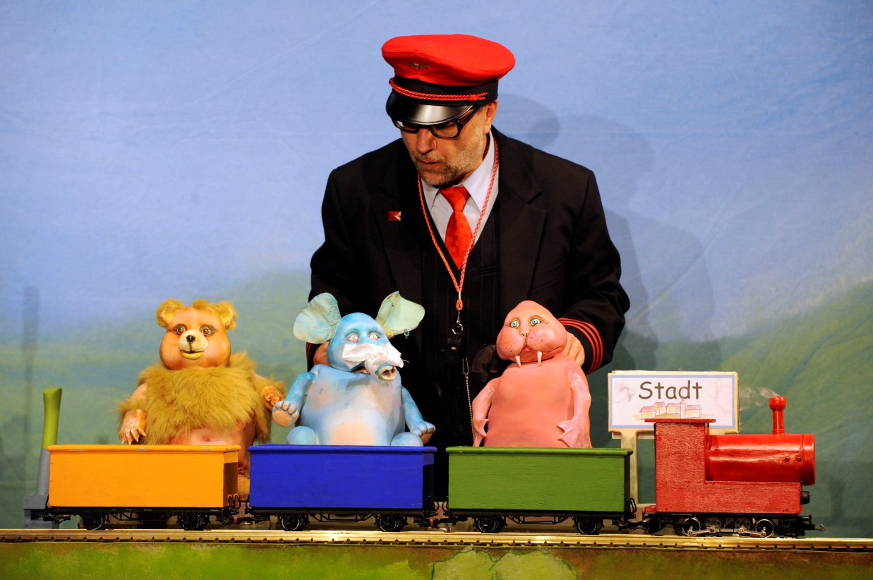

The animals are round and big and very limited in what they can do, so the children can identify with them easily and form a "community" with them, even "against" the train driver. In this way, I hope to reflect the children’s relationships with their parents for them. The animals try to behave as best they can and do everything in the right way, but this doesn't always work, just as it happens with children. The animals need the train driver’s help, but sometimes he is quite stressed.
Like children, the animals are not always "cute": Mr. Beaver is always very tired, Mrs. Elephant likes to kiss too much, etc.

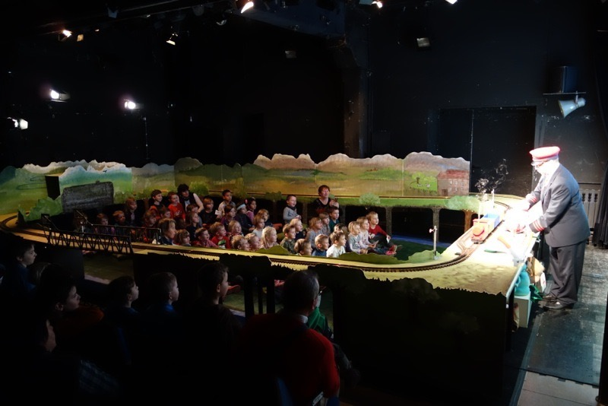

Seating the children inside the set is a primary element of the structure, and the basis of the dramaturgy of involvement
A special song was composed for this show, sung by the puppeteer, sometimes together with the children.
When the show ends, the set opens, the children leave and are again in their normal reality – the real world. The experience of "another reality" starts and ends in a very clear way.
Thank you.

Naomi:

Thank you Sibylle!
I would like to invite Mrs. Ajda Ross, Artistic Director of Lutkovno Gledališče Ljubljana (Ljubljana Puppet Theater), Slovenia. Ajda will speak about the show “Turlututu” as an interactive performance for small children.

Ajda Ross:
“Turlututu” – An interactive performance for small children

The Ljubljana Puppet Theatre is a big theater, with six stages, 23 actors and 11 performances per year. About 50% of our shows are for ages three and up, two performances per year are for ages six and up, and there is one performance each for teenagers and adults. In fact, many toddlers come to our shows.
Our new show, which you can get a taste of here, is a good example of how to create a performance for toddlers:

As the title of my speech indicates, toddlers are used to interactive encounters. We cannot expect them to be quiet, to sit still, not even in the theater. There is no conventional border between an audience of toddlers and the actors; they are all together. And so, in this example, we can see that the space is designed as a circle divided into six spaces, and the toddlers sit between the acting areas.
Maya, the actress in the show Turlututu, which we are presenting here in Jerusalem, is also the actress in our new show, and this is not a coincidence. For me, it is crucial to find a person who is able to be in such close interaction with very small children. The actor’s energy is very important. We have 23 actors in our theater, and Maya features in most of our performances of this type.

What are the principles of our interactive shows for toddlers?

- Space – No boundaries between the children and the stage

- Music – Always use live music and singing

- Words – Words are not very important, as theater can speak on very different levels: with music, with images, with movement.

- Story – We found that the story is also not that important. Instead, the dramaturgy is based more on fragments.

- Images – There are a few very strong images and, for me, it is very important that they all leave space for the child to develop his/her own imagination and be open to share what he/she has found there. The children are not just spectators. They can co-create their own performance in their minds..

- Preparation of parents, children and artists – We found that it is very important to prepare parents and other adults who come to this kind of performance. Our artists always consult with psychologists, as it is important to understand toddlers. We know that they watch performances with curiosity, that they are happy, sometimes loud, sometimes afraid, sometimes they have to go to the toilet during the performance… or they are hungry… So it's important to prepare both parents and artists to cope with these things. On our website, we have some very polite instructions about preparing the child for the performance, because sometimes it's their first experience of theater, their first experience of Art.
Before the show starts, we say a few words about how to watch and participate. At the beginning, we didn't say anything; we expected the children and parents to know how to behave in the theater. But later, we added a few very polite words, and it made them feel more confident. We tell the parents that it is quite normal when children cry: "You can hold the child, you can hug him, go out for a while and then come back," etc. It really works well this way.
On our web page, we also have some instructions and suggestions on how to connect with the performers after the show. We always prepare some drawings for the children to take home, to paint and play with.

Turlututu:

This show is an adaptation of a book by Hervé Tullet. The book is already interactive, with a "touch & feel" style, and it offers a lot of ideas for the performer. At the beginning, the show was supposed to be for one-year-old toddlers, but now it's mainly for children two years of age and up. In this kind of performance, the performer’s energy is very important. The children really co-create the show – they are equal partners in creating the event.
I would like to ask Maya, the actress, to tell us about her experiences and about the connection between the audience and herself as performer.

Maya:
For me, acting in front of such young children is a completely different experience from acting in front of five-year-olds. What I discovered was that you really have to be present in the situation, and you need to be very sensitive to the children because they are so small. You cannot really expect them to sit still, to behave, to be polite, to be quiet; it is normal for a toddler to move around. So I need to have very present, grounded energy.
Hervé Tullet’s books are themselves quite abstract, so they leave a lot to your imagination. For me, it's not so important to have a story, just impressions, so the children can make up their own story. There is a basic storyline that some children may recognize, but it's not necessary. You get the impression from the sounds, the visuals, the impact.
The process of creating a show for small children is very interesting because it is totally different – you can’t hide behind the puppet and you can’t hide behind the words. You are basically naked, creating everything by yourself. It’s a very powerful experience.

A trailer of Turlututu

Naomi:
We are very happy to host Stanislav Doubrava, Director of the Naive Theatre and the Mateřinka Festival, Liberec, Czech Republic, and Vítek Peřina, Dramaturge of the show “About the Lamb that Fell from the Sky,” at our festival. They will speak about the basic principles behind their first show for toddlers.

Stanislav Doubrava & Vítek Peřina:
“About the Lamb that Fell from the Sky” – Basic principles of our first show for toddlers

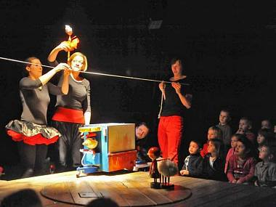

Stanislaw Dubrava:
The Theatre Liberec, founded 65 years ago, and the Materinka, the Puppet Festival, are bringing performances for the smallest, preschool aged, children into their focus. I would like to stress that we do not specialize in theater for such small children, so this performance was our first try, a new step for our creative team, led by Vitek Peřina .
Some of you have already seen the show. We are very proud that this performance was ranked among the three best Czech theater shows for 2014, in the branch of general theater.
I would like to ask Vitek to talk about this performance.

Vitek Peřina:
I wrote down a few points about questions that we had to solve during the preparation of the show, and a few principles that guided our work on "The Lamb that Fell from the Sky". Let's first watch the trailer for the show.

We had no experience with this kind of performance. It's very funny that the children are in the same situation, because often, it's their first time at the theater. So we are on the same level, and maybe that’s why it all works…
Our initial inspiration for this performance was Mateřinka (theater for preschool children), and we were looking for a topic that would be suitable for very young children, with a simple storyline focused on perception.

Toddlers as audience:
Our director, Mrs. Michaelova, is also a preschool teacher, and she did a lot of research for the project, read a lot of literature, talked with her colleagues, etc. She discovered things that we didn't know, for example, that children younger than two are not aware of things they don't see at that moment, or that they cannot form sentences more than three words long… This preparation was necessary because we are beginners.

The topic:
The book "The Lamb that Fell from the Sky" was written by Fred Rodrian, and published in 1957. When we decided to create a show for children aged two years and up, we took some motifs from the book – the fair and the synopsis of the storyline – but we had to change the story completely. We used the beginning and the end of the story, but we had to completely change the plot to adapt it for ages two and up. For example, in the original book, there is no circus whatsoever… As Ajda explained, we looked for fragments rather than narrative; very simple situations.

Space:
As for the acting space, we decided very quickly that this must be an intimate, contact-oriented area, with close, intimate contact between audience and actors. Of course, this makes it impossible to perform for 200 children at one time.

Acting approach:
What we didn't know, and learned only during rehearsals, was that we had to use a completely new acting approach, entirely different from the one we’d used previously, especially when it comes to time perception. For example, the performance begins with the entrance of a girl, greetings to the audience, and the characters coming onto the stage. It's a ritual, rather than just bringing the puppets out and using them. We used this approach throughout the performance.

Team Building:
We also had to give special attention to team-building with the actors. It was important to create harmony between the actors and the production team.

Music:
We use live music made with everyday objects – wooden sticks, iron sticks, etc. – the reason being that we wanted instruments that would be accessible to young children, which they could use, instead of adult instruments that are not suitable for them. And after the performance, they could try out these instruments and play them. This was our intention.

Language:
One of the main problems in this kind of performance is finding the right stage language. We went through a few phases in our research. At the beginning, we wanted a completely non-verbal performance. But that didn't work. Then we started to think about a newly created artificial language for all the characters. This didn't work either. Finally, we decided to use four different languages, specific to each of the four characters. The girl speaks a very basic Czech, understandable for toddlers, with very basic, simple, maximum two-word sentences, e.g. " sheep go," "sheep, come!" The sheep only says "be beee." The boy only whistles. The principal of the circus is the only verbal character, but he uses an Italian-Czech "language," specially modified for the show.

Set design:
Our choice of visual attributes was influenced by the tradition of jigsaws and wooden toys, some of them made in the 1930-1940's in the Czech Republic. We were also inspired by Robert Smolík and the works of Czech modernists – Minka Podhajská (toy maker, artist), Ladislav Sutnar (designer, artist, print maker).
Another inspiration for the artistic team was Alexander Calder’s "Circus," which we saw during our visit to the Whitney Museum of American Art in New York City. We decided to make the kind of puppets widely used in the Czech Republic.

Sometimes, during rehearsals, we had to go back to what we had initially decided and to our initial intentions, i.e. no narration, direct contact with children and performing in space.

Naomi:
We are lucky to have our dear friend Antonio Catalano come to our festival with his show "Tic Tac Tic Tac," and join our panel. Having created his unique "sensitive worlds,"' Antonio will now speak about his sensitive worlds for toddlers.

Antonio Catalano:
“Tic Tac Tic Tac” – The creation of sensitive worlds for babies
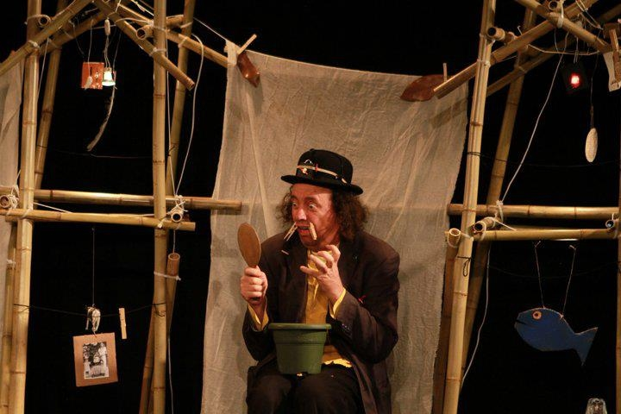

I am very confused. I know nothing. After so many years of doing theater, I know nothing. Nothing. I don't understand. I don't know if theater for children exists. I know that theater exists. A good show, possibly poetic, and for everybody, because childishness is a gift that even children can have. But it's not exclusive to children. It's inside us, outside, somewhere.
If I create a performance that they, and I, like – I am glad. If I do a work that I don't like – I am not happy.
What I say is not very interesting.
I think that one of the things that one has to do is talk about fragility, vulnerability, understanding, compassion. Maybe this is what we need. We don't need to talk about theater. Maybe we need to talk about life. And since I don't understand anything about theater – life is a tragedy. I am in a situation of total confusion and this is an ideal situation to begin to create. Not to know, to be vulnerable, possibly simple, which is very difficult, to be simple. No, I don't understand anything.
I am very much like a donkey, because I understand afterwards, much later. I have understood things after 20 years, and still, I have doubts. When my mother presents me, she says: "This is my son (boy). I have made him and I have not understood anything." So if my mother doesn't understand anything, we have to give up. We are in a situation in which we basically don't understand what we are doing.
We have to bring the mystery back to our work, the poetry. I would like to make very experimental, avant-garde theater for children; a theater that is not understandable, in which the dramaturgy goes by association. Like poetry.

Before I tell you what I am doing, I would like to talk about the thing I am exploring, which is an artistic movement called "Theater of Poor Pedagogy."
I live in northern Italy, in a special house. It’s special because there is a theater inside this house. We have a small open theater, we have conferences and also performances. It's the only one of its kind in Italy: a house bought by a group of artists who live and work there. A lot of important people have come there – the Living Theatre, Judith Malina, many sculptors, writers etc.

At the Venice Biennale in 1999, I presented a work called "The Sensitive Wardrobes." I started to think that we had to get rid of the concept of "performance." We created a new word: "Encounter." So I left the stage and started building worlds.
I do everything. I’m a sculptor, painter, performer – everything: the artist, the baker, the carpenter. Because I am a Renaissance man, and the Renaissance man did everything himself.
In "Sensitive Wardrobes," the public entered the wardrobes, and inside them, there were worlds.
The fundamental concept for me is the work of Wonder. After the “Sensitive Wardrobes,” I did “Sensitive Worlds.” I created more than 100 sculptures. I went to town, to old folks’ homes. I took photos of old ladies and transformed them into Sirens. "Beauty is in the eyes of the beholder."
I create suitcases. Everyone gets a suitcase in which he/she can tell/listen to a story.
I create carousels. I have three of them. Inside them, there is a library. There are more than 700 books in each carousel.
I paint Chapels of Wonder.
Wonder is the essence. I create chapels where we can come and be struck with wonder. Many teachers come and listen to my poor pedagogy.
Fragile worlds. I create the scenography with the spectators and, at the end, the spectators take it away.
I create laboratories of vegetable materials: bread, earth.
My fragile performances are: “Tic Tac,” “Fragile Concert,” “Dream,” “Sky of Bread,” and the new performance, “Boh,” a homage to the clown Charlie Rivell.

Naomi:

We've asked a few experts to contribute some of their insights to our panel, and to share their psychological and educational experience with us. Dr Shlomo Ariel, a clinical psychologist and family therapist, is, unfortunately, unable to join us today. I will now read his comments about Theater as a research laboratory of early childhood

Dr. Shlomo Ariel:
Theater as a research laboratory of early childhood
Children up to the age of three are enthusiastic scientists, who research their own self and their environment incessantly, always wondering, taking great joy, inventing countless scientific experiments and, meanwhile, growing and developing at full speed.
They develop everything: their senses, their conceptual and creative thinking, their language and interpersonal communication, their relationships, their motor abilities. They interpret the world in their own ways. All this, of course, within the framework of the yet limited capacity of their developing brains and their modest capabilities.

A theater targeting toddlers might evoke tremendous curiosity, excitement and much fun and enjoyment, if it became a micro research laboratory for them. Essentially, this would not be very different from laboratories in the big world, but would still provide the means for diverse experimentation in a more focused and concise manner.
These experiments should be very short and simple but, at the same time, surprising and unexpected.

Examples and ideas for theater as a laboratory:

1) Toddlers are invited to caress actors who impersonate diverse creatures, wrapped in "skin," fur, etc. In some cases, touching would elicit surprise, e.g. if the fur would feel stiff (sense of touch).

2) Actors would use their voices as percussion or musical instruments, or to produce strange and unexpected sounds, e.g. one actor would make a low sound, as if from a wind instrument, while another actor would try to do the same, but would instead produce a high, quivering sound.

3) Actors could encourage toddlers to make voices and sounds (sense of hearing).

4) Actors would personify chameleons, which change color. Actors and children mixing colors would create new colors, with which they could paint (sense of seeing).

5) Letting toddlers sniff materials and objects. Mixing materials would change the smell (sense of smell).

6) Tasting sweet cookies. But some of them, which look the same as the others, would be salty or sour (sense of taste).

7) Human beings, animals or objects disappear or vanish, but then they pop up again (the stability or instability of objects).

8) Giving names with funny sounds of different types, to creatures.

9) Using the same short word in different contexts, e.g. "enough" in the sense of "not so much" or "stop annoying me” (flexibility of sound, words, concept).

10) The children in the audience are animals in the Safari, fed by the actress (relationships and loving care), and more and more, as much as the creative imagination of the director/actor produces.

Naomi: Ran Cohen-Aharonov is an early childhood specialist and children's author. I would like to invite him to present his perspective about the importance of theater and puppet theater for toddlers.

Ran Cohen-Aharonov:
Why is puppet theater beneficial for young children?

I am an educator. I used to have a kindergarten for toddlers. I write children’s books. Now I am learning about children’s theater, because my last book was adapted as a play. The word "dramaturgy" Is a new word for me.
I will try to speak about some of my ideas about theater for toddlers.
When I was a kindergarten teacher, everybody told me that children start to communicate with each other at the age of three.

To start with, let’s have a look at this video.

What we actually see here is conversation, humor, dialogue, communication – in short, theater.

Communication:
Communication is a spiral. It starts very early and changes continuously. Children learn about the world through communicating with others. In theater, the communication is on a very different level than in school or kindergarten: it aims at seeing the world differently.

Learning:
We start learning from the moment we are born. In the theater, children can learn using all their senses, as well as through experience.
Children are curious, but if the environment does not encourage them, learning won’t happen, or it will happen late.

Fun and joy – how?:
The play has to be interactive. Humor is welcome. Noise is welcome. Children should feel accepted. Movement is welcome.
We have to be respectful toward children, to talk to them at eye level and not treat them in an infantile way.
Adults can also enjoy theater for toddlers. Watching a show with an adult is an opportunity for mutual sharing and enjoyment, and it helps the child feel more comfortable.

Naomi:

For the final part of our panel, we asked a few of our colleagues at the Train Theater to give presentations about their special interest in puppet or object theater for toddlers. First, I'd like to invite Shachar Marom, whose main interest is in object theater. We discussed the difference between passively watching "Baby Einstein," one of the most popular TV programs for toddlers, and the theatrical experience. Is there a difference? These questions about the different media for toddlers led Shachar to offer his own personal interpretation, experimenting with object theater on the same topic as a Baby Einstein program – circles.

Shachar Marom:
Baby Einstein vs. Object Theater – "Circle" can be seen here.

Naomi: The main activities for toddlers at the Train Theater have to do with storytelling. We have not as yet produced a full show for toddlers so, in a way, this seminar is an important opportunity for us to learn from our guests.
As we approach the end of our meeting, it is amazing to realize that there is so much interest in this field, and that there is such diversity in the directions theater for toddlers can take.
I would like to introduce Hila Flashkes with an illustrated story from her work in progress.

Hila Flashkes:
Opher and Ophra, an illustrated story by Oded Burla, can be seen here.

Hila tells the story:
Once upon a time, there was a girl. Her name was Ofra. Ofra has blue eyes and yellow curls. Ofra has a friend, Ofer [deer]. Ofer has brown eyes, a black nose and a white tail. See?
Ofer and Ofra went for a walk. Ofra picked a flower. Ofer ate a flower. Ofer saw a butterfly. The butterfly sat on the tip of Ofer's nose and was not afraid. Then another butterfly came and sat on the tip of Ofra's nose.
Nice?
Ofer hides behind the flower and Ofra says: Where is Ofer? Where is Ofer?
Here is Ofer!
Ofra also hides behind the tree and Ofer looks for her. Where is Ofra?
Here she is!
Now that's enough! Let's go home!
The butterflies go home too.
The flowers don't go anywhere. They are here to make the world beautiful.

Naomi:

Next year, we intend to open a course for puppeteers who are interested in theater for toddlers, at the Train Theater. I would like to invite Galia Levi-Grad, a puppeteer and storyteller who will teach the course, to present her mentor – Shushu the Cat.

Galia Levi-Grad:
Shushu my Mentor: Puppets in storytelling for toddlers

You can watch Galia’s presentation here.

Galia:

I was very lucky to find a mentor who guided me in my story hours for toddlers. He taught me how to connect with toddlers, and even babies, by connecting my own inner child with today’s toddlers.
Luckily, he is with us here now.
Shushu? (Enter Shushu, a glove cat puppet). Shushu! (Shushu runs away).
I am not surprised that he doesn't want to stay. He doesn't know how to communicate with adults…
Let me tell you how he became my mentor.
My story hours for children four years old and up are usually created as a laboratory on the way to a full show. In my shows, I explore different uses of paper, like pop-ups, origami, abstract forms or geometrical objects.
Unlike my works for older children, I felt intuitively that, for toddlers, I needed a mediator, so I made a puppet of a cat – Shushu – as a mediator between me, my own inner child and the young audience. Shushu was created as a toddler himself, and he will always remain a toddler, even though he is my oldest puppet. He gives the children the opportunity to peep into the world of stories, and reveals to them, for the first time in their lives, the world of theater.
(Shushu peeps in and interferes) Sorry…
Indeed, Shushu is a link between stories, games, emotions and themes. When a child loses concentration, Shushu is there to refresh the subject with some surprises.
(Shushu interferes) Sorry…
When I ought to change or clarify the subject, Shushu is there to give me a sign. Through trial and error, I realized that, with toddlers, I have to operate with short units and small items that stimulate them when they lose concentration. Shushu is the one who connects the different parts into a whole. His attention, his understanding or misunderstanding, and his emotions give me a clue as to where the toddlers are. As a matter of fact, Shushu is an additional toddler in the audience, who reminds me to pay attention to him and to react to him.
Shushu encapsulates my own inner child. For me, he is the key to a world that is usually locked for adults. He was born 25 years ago, but he is still identified with me to this day. Grown-up children sometimes call me Shushu. Sometimes they don't remember my real name… Over the years, Shushu's fur became shabby and old, so I decided to replace him with a new puppet: a cute felt dog, but… (Shushu interferes) Sorry…
The toddlers’ reactions were cold, to say the least, and I understood that Shushu's roots are planted too deeply within me. So I created the "Improved Shushu Junior," and together, we stepped into the original Shushu's shoes…
Thank you!

Naomi:

I would like to thank all the participants in this panel. I am sure that this short meeting has enriched us all immensely. It has given us and our fellow puppeteers, researchers and educators many ideas and clues for further investigation and experimentation toward creating beautiful new shows for toddlers – where it all begins! Thank you!

